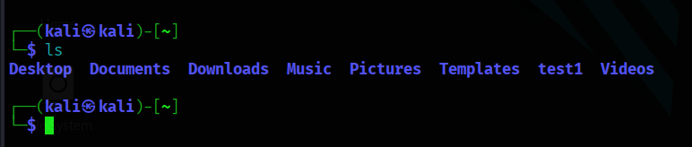
ls – gives list of files and directories

Touch – creates an empty file
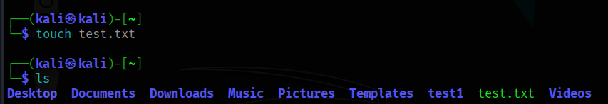
Cat – shows content in the file



Mkdir – makes directory

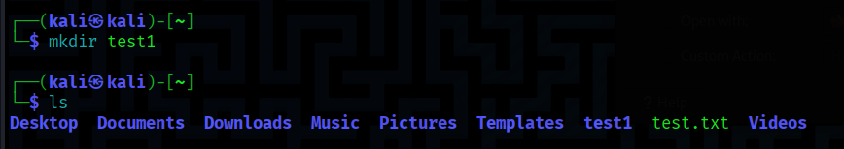

Mv – moves or renames present file

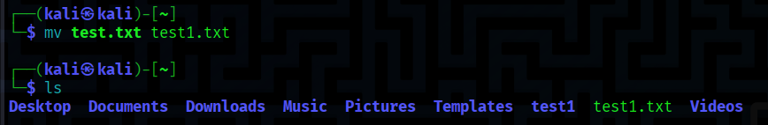

Uptime – gives time and average load

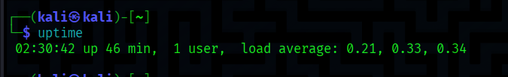

More -displays file page by page



Date – shows date



Cd – changes to given directory

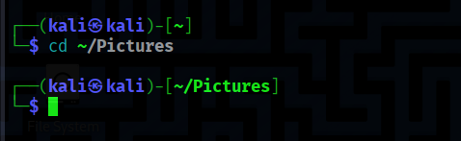

Users – shows all users

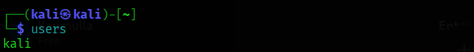

Wget – downloads files from internet

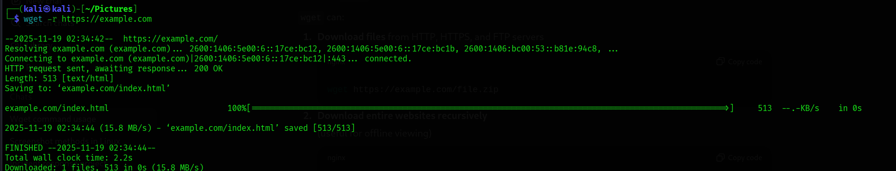

Pwd – shows present working directory

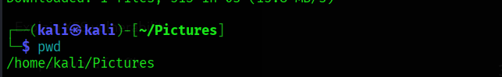

Head – shows first 10 lines in file

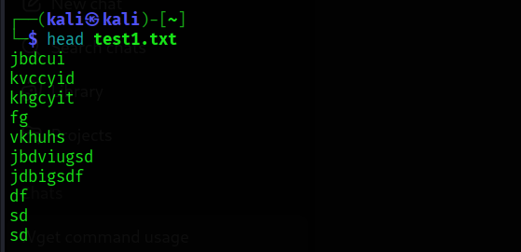

Tail - shows last 10 lines in a file

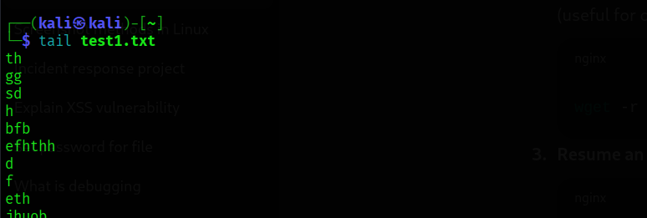

Sort – arranges in order

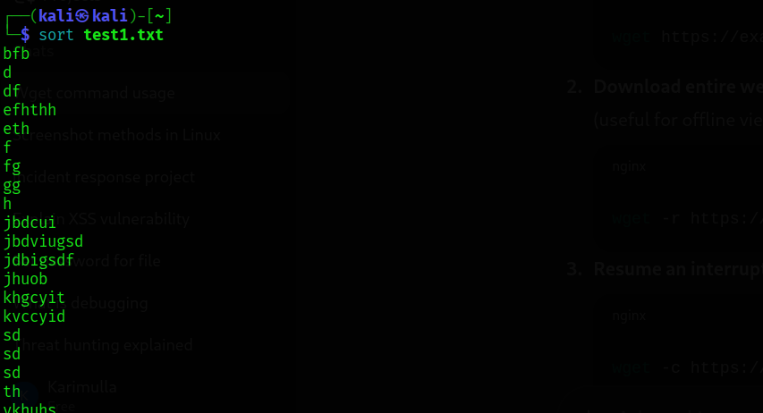

Rm – removes files

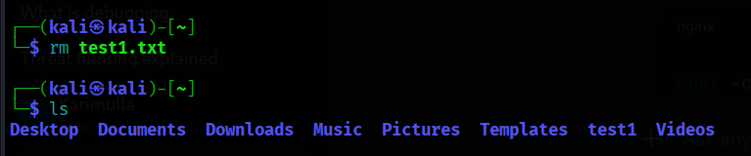

History – shows all activity we done before

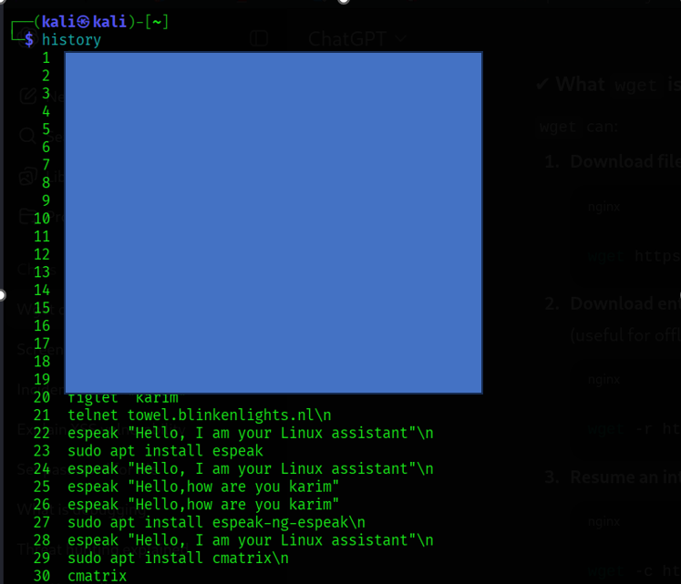

Cp – copies content one file to another

